Data Subject Request Form

This form enables external stakeholders (including suppliers, clients and other business partners) to exercise their rights regarding personal data processed by WIOCC Group in accordance with applicable data protection laws.

Please complete all parts of this data request form and send it to dpo@openaccessmetro.net.

Please specify:

☐ I am a WIOCC Group Supplier
☐ I am a WIOCC Group Client
☐ I am a former WIOCC Group Supplier
☐ I am a former WIOCC Group Client
☐ Other

If other, please specify:

Details of Requestor

Full name
Contact No.
Email address

Are you making this request on behalf of a data subject?
☐ Yes
☐ No

If you are making the request on behalf of someone else, we need to know who they are and their contact details in case we need to get in touch. Please provide the following details:

Name:
Relationship with Data Subject:
If not a minor, contact information of data subject:

Data Subject Request

Please choose the request you would like to submit and provide details. When providing details please specify the data you wish to access, rectify, or delete, and include relevant dates, reference numbers, or additional context.

Type of request |  | Details of the request
Right to access  Please provide how you would like to access your data and/or how you would like it delivered to you | ☐ Yes
Right to rectification | ☐ Yes
Right to erasure | ☐ Yes
Restriction of processing | ☐ Yes
Object to processing | ☐ Yes
Data portability (transfer of data)  Please provide details of the recipient and the mode of transfer you would like | ☐ Yes
Withdraw consent | ☐ Yes

Declaration

By submitting this request, I acknowledge and agree to the Privacy Policy https://openaccessmetro.net/privacy-policy/. I confirm that I have the right to make this request, whether it concerns the processing of my personal data or if I have obtained authorisation from the data subject whose data is included in this request. I also verify the accuracy and correctness of the information provided in my request. I understand that my request, along with its contained data, will be processed to address my inquiry.

We may require additional information from you to properly process the request. We will provide you with information on any action taken regarding your request within one month of its receipt. That period may be extended by two further months where necessary and in this case, you will be informed of any such extension and the reasons for the delay. In any case WIOCC Group is obliged to confirm your identity before taking any action to process a request. We may request that you provide us with proof of identity. If you act in the capacity as an authorized representative, you should be able to provide proof of your powers upon our request.

We may refuse to act on your request on legitimate grounds for the existence of which you will be duly notified. In some cases, we may charge a reasonable fee taking into account the administrative costs of providing information or communication or taking the action requested.

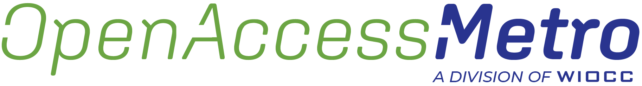

Mauritius  9th Floor, NeXSky Building,  Cybercity 72201, Ebene,  Republic of Mauritius  +230 466 9171 / 464 9799 | South Africa  Corner House, Leslie Road Retail Park, Cnr. Winnie Mandela Drive and Leslie Road, Fourways, Johannesburg, South Africa  +27 011 030 0000 | Nigeria  3b, Bosun Adekoya Street, Lekki Phase 1, Lagos, Nigeria  +234 20 1 8870 050
Zambia  Piziya Office Park, Stand No.2374, Thabo Mbeki Road, Mass Media,  Lusaka, Zambia  +254 20 421 2000 | Kenya  Citadel Building - 3rd Floor  Muthithi Road, Westlands, Nairobi,  Kenya  +254 20 421 2000 | info@wiocc.net  www.wiocc.net

